final Report

Juan Garza, Jonathan Rodriguez, Eduardo Cruz, Samuel Pacheco

## **Corridor Expansion**

### *Descriptions*

Our team engaged in extensive discussions regarding how we wanted the game to shape up regarding its map and area. We wanted to make sure that the dungeon was as organic and natural looking as possible. The algorithm implements a serious modification to the algorithms using the previous corridor first algorithm to alter the making of it. The current corridor is 1 tile in width, but we are expanding it to 3 tiles. We are going to take the first tile of the corridor and then the next one and check the direction they are moving, after that we can add two tiles to the right as it moves along. I used a YouTube guide as previously used to implement the algorithm into our game.

### *Scenarios*

As previously shown the corridor was established just as to traverse from one room to the other, in testing the player (depending on the generation of the map), could get stuck with an enemy in the corridor making it challenging to make it to the next room. The algorithm changes this my expanding the corridor.

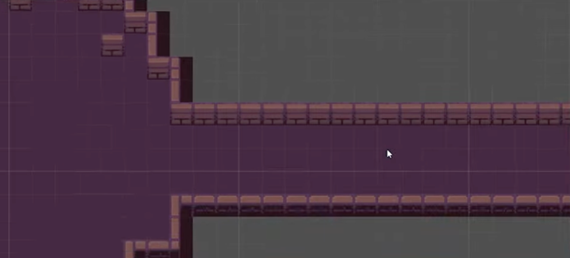 As you can see the corridor expansion really makes it easier to navigate from one room to another.

Corridor expansion:

<https://youtu.be/jCVa4O4RksU>

## **High Level System**

### *Descriptions*

When establishing the game mechanics, we decided that the boss should be in a different scene all together, but we needed to ensure before then that the player would spawn in a specific location along with anything that player needed to traverse. This algorithm implementation was gathered from a YouTube tutorial while the creation of the corridor was being developed. We did not apply it until we were ready to create the first iteration of the boss to ensure that the player spawned in a designated room called player room.

The player being places in the dungeon with items alongside the player. The player room ensures that the player has all the necessary things needed for the room. While I implemented the algorithm to make this functional, Jonathan was able to utilize it fully.

## **Game Over Screen**

### *Descriptions*

When the player was slayed, the game would usually just stop working, we needed a way to visually help the player have a choice when slayed. A game over screen was implemented with the idea of giving the player three options, to restart the game, to go to the main menu, and to quit the game. I followed a simple YouTube video on the matter and worked with my teammate Eduardo in ensuring that the game over screen would traverse to the menu page he created.

A simple game over screen was implemented to ensure the three functions helped the player get to where they needed to get after they were slayed. As shown the player was three options to use from.

## **Music**

### *Descriptions*

While implementing the entire game, music was something that we wanted to ensure we got it right from the start. We were able to find three options for the main menu, in dungeon music, and also boss battle. I was able to implement them using a couple of empty objects and using the audio component. Following a simple YouTube video, I was able to complete this task. The following three songs were chosen from a royalty free website:

Ava Low - Into the Prism

<https://www.epidemicsound.com/track/JusvqlEULL/>

Lexica – Helios

<https://www.epidemicsound.com/track/HLklhDSNTw/>

Lupus Nocte – Astrophage

<https://www.epidemicsound.com/track/t40NyOP3s9/>

# Code

I followed multiple YouTube videos to ensure that everything that I worked during the last 2 quarters were completed correctly.

Corridor expansion:

<https://youtu.be/jCVa4O4RksU>

High level System:

<https://youtu.be/t1a1QBcfRlM>

Game over Screen:

<https://youtu.be/pKFtyaAPzYo>

Music:

<https://youtu.be/KOf3P5y19Bw>

Algorithms showcasing the alteration of the corridor.

Algorithm showcasing the game manager script used in the game over screen.

An empty object was created in the addition of the music for all scenes used in the game.